Workshop Trainers Guide
  - Practical Spec-Driven Development with Windsurf and GitHub Spec Kit

1. Environment check and workshop framing/intro
Check if the attendees have license assigned on https://windsurf.com/profile. The account subscription should be Cognition Platform (Enterprise).
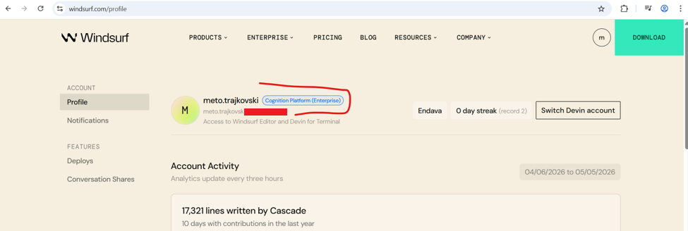
Check if the attendees have successfully installed the Windsurf IDE locally.
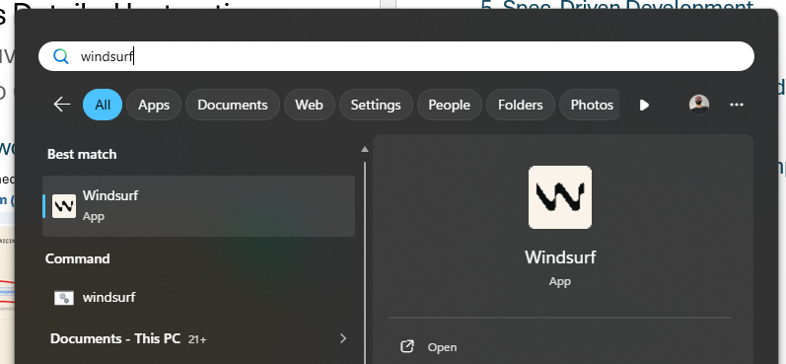
Check if the attendees have logged in successfully in the IDE locally (the right bottom corner of the IDE (below the input field) it should say Cognition Platform (Enterprise)).
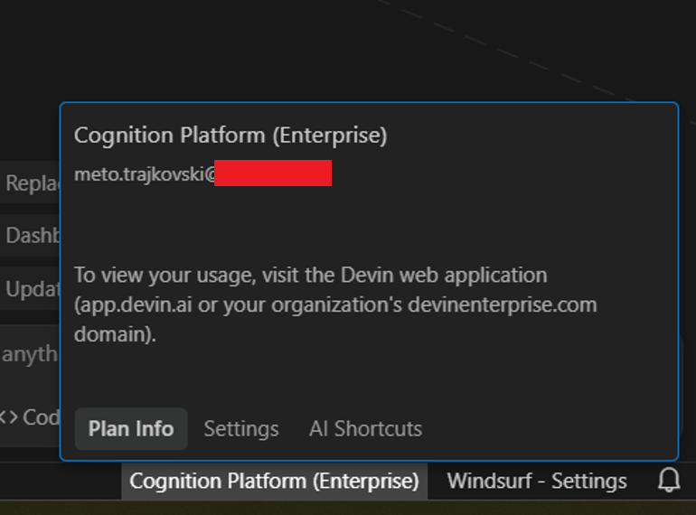
Check if the attendees have successfully installed NodeJS (node --version) and NPM (npm --version).
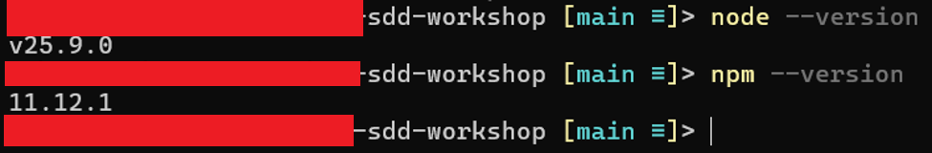
Chek if the attendees have successfully cloned the project source (for what they needed GitHub, git, SSH setup) and are able to successfully run the project (npm run dev) and e2e tests (npm run test:e2e - Note: 2 of the e2e tests should fail – they will be fixed later).

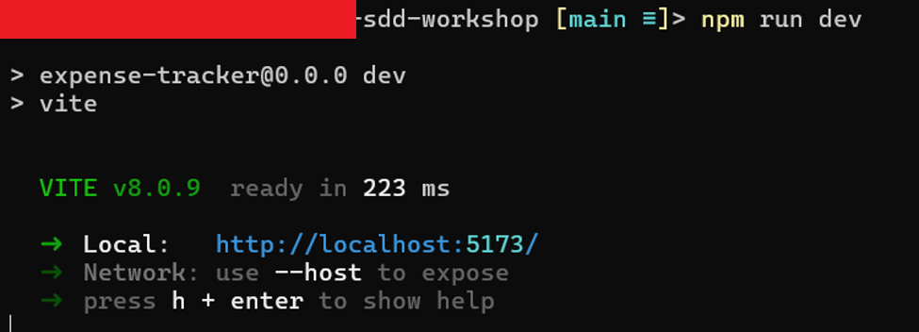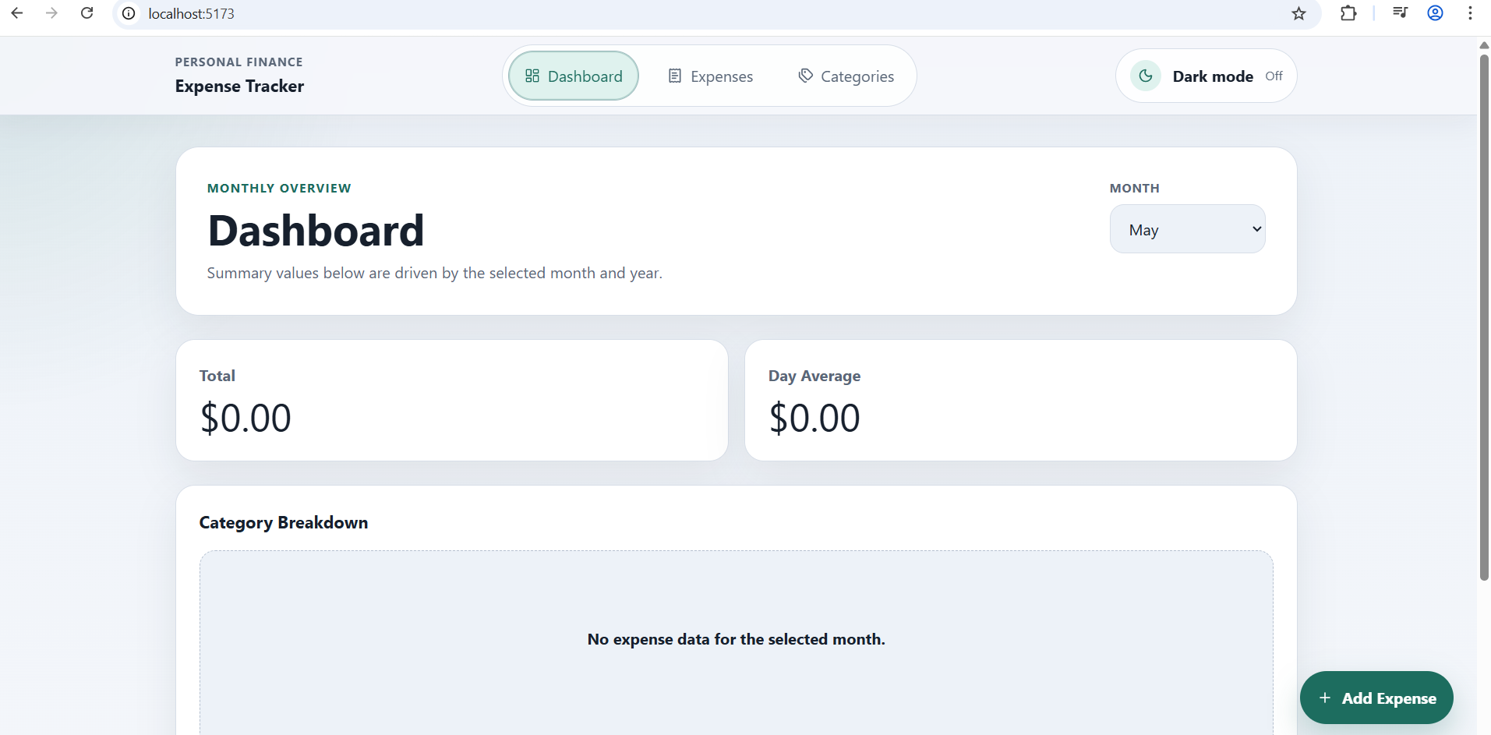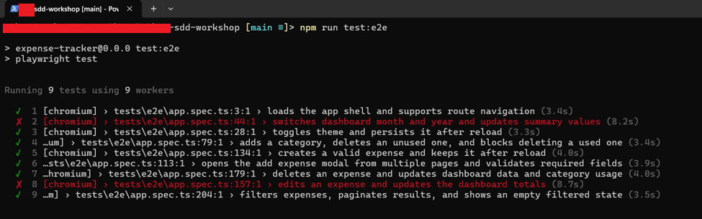
In the end remind the attendees that they should clone/download use the Resources folder, because all the resources used later could be found there:

2. Windsurf orientation
Show how to open a project. And show the project explorer.
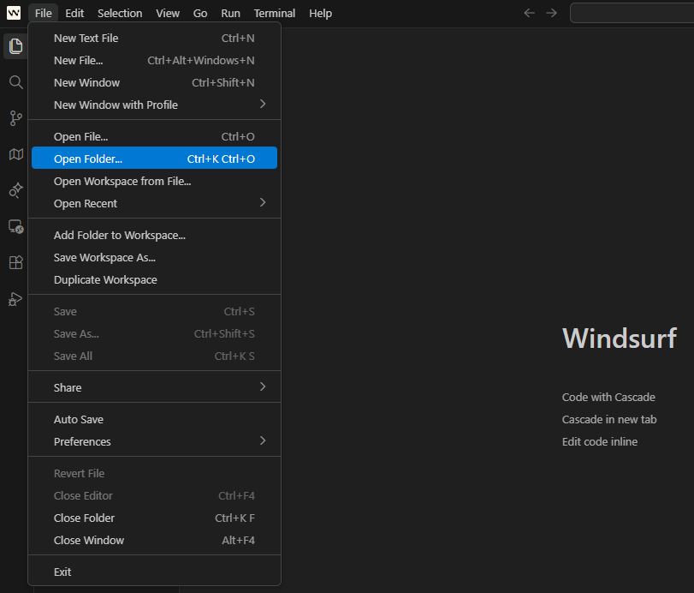
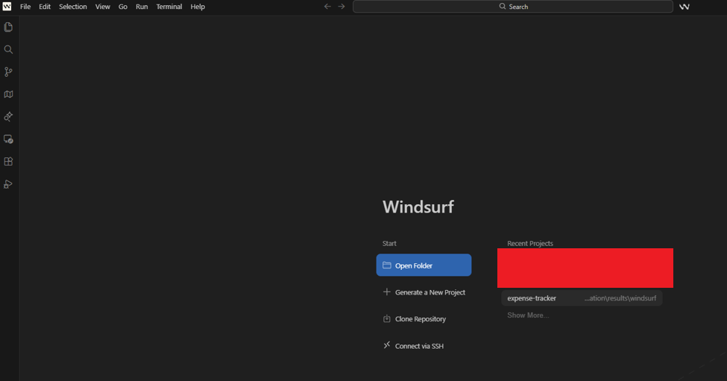
Open terminal and execute some command (example: npm run test:e2e)
NOTE: some of attendees could be facing issues with the Windsurf terminal usage, in that case they can continue using the terminal that works for them – with Run as Administrator)
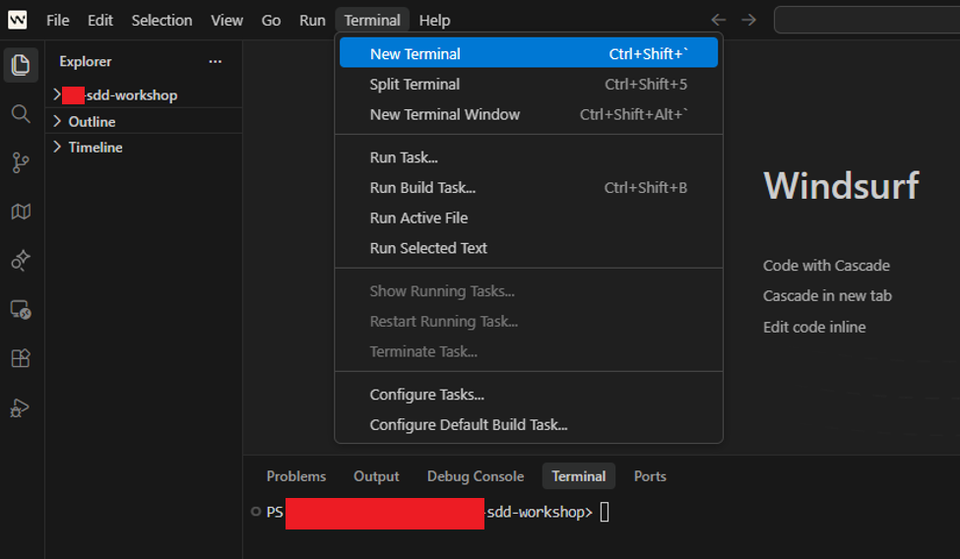

Open windsurf settings (two ways to access it). And under Cascade choose Disable for all these 3 options: Auto Execution, Auto Web Requests, Auto-Continue (because we want to use it like a co-pilot and not autonomous agent)
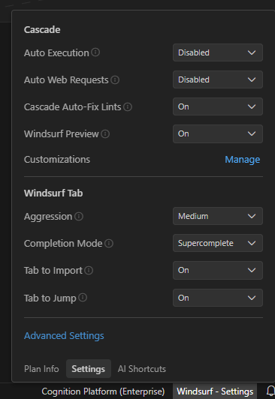
Or
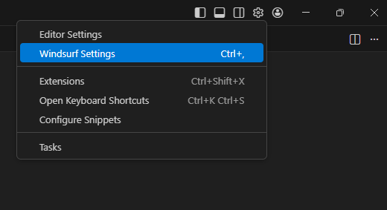
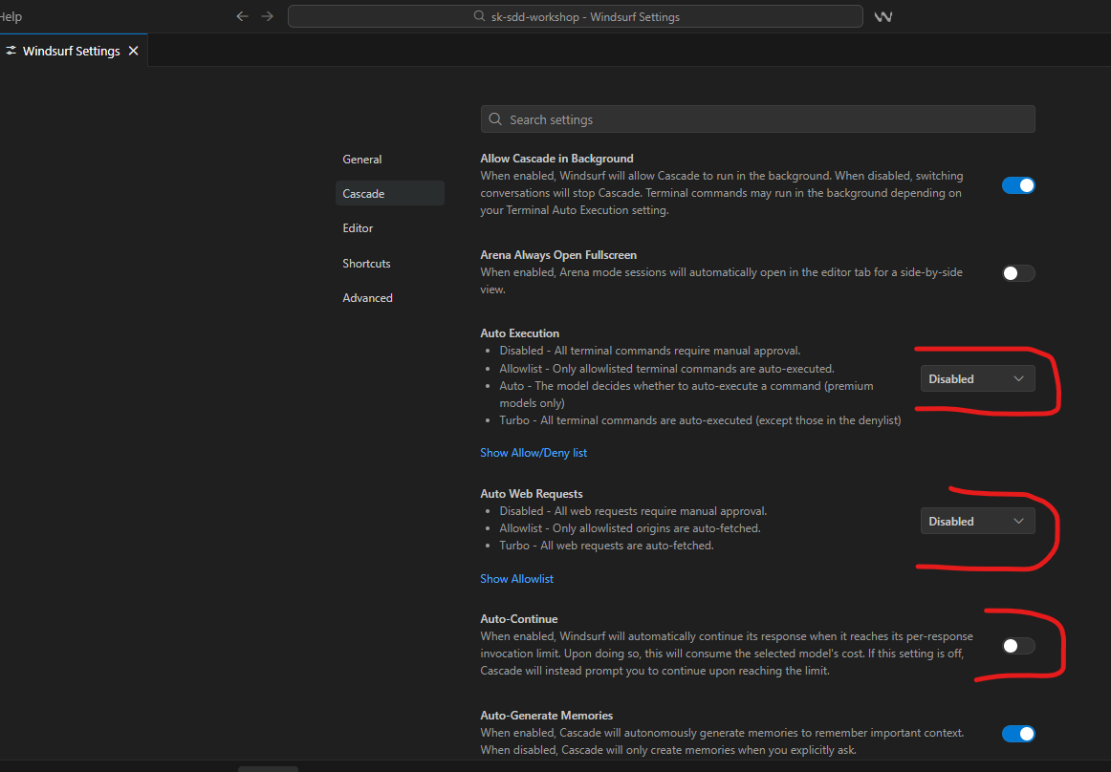

Open Cascade using Ctrl + L.
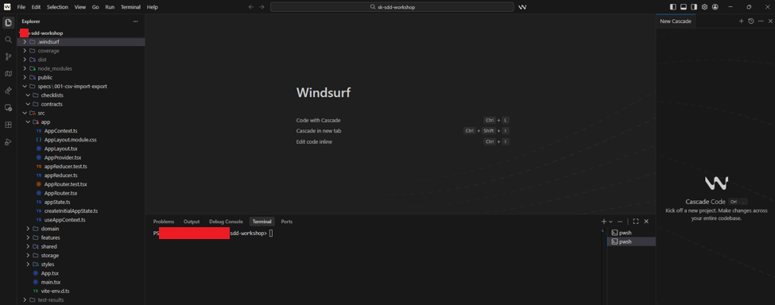
Choose a mode for Cascade.
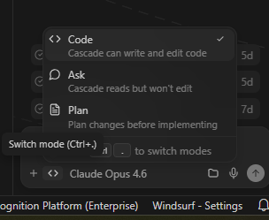
Choose a model for Cascade.
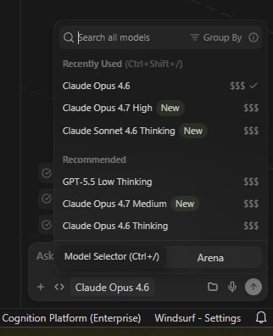

3. Prompt warm-up
Start with Ask Mode with Claude Opus 4.6 (faster than Claude Sonnet 4.6, and don’t use it in thinking mode).
- Explain that the Ask Mode works only in Read Mode (does not edit files)
- Find the prompts in \Resources\3. Prompt Warm-up\Prompt_1-ask_mode.md and \Resources\3. Prompt Warm-up\Prompt_2-ask_mode.md
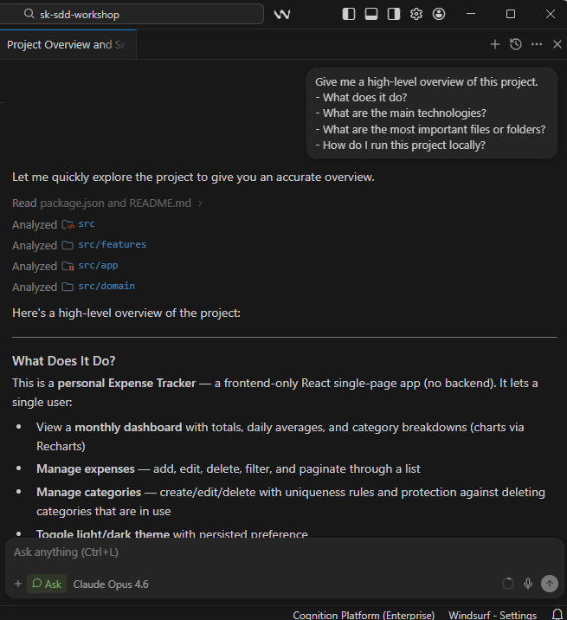
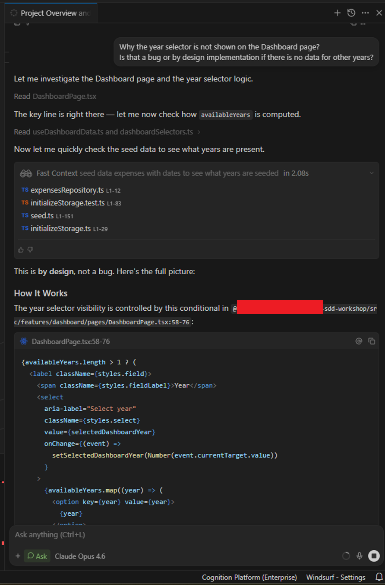
Proceed with Code Mode to fix the 2 failing E2E tests and 1 unit test.
- Show how to accept file changes and accept commands to be executed
- Find the prompt in \Resources\3. Prompt Warm-up\Prompt_3-code_mode.md
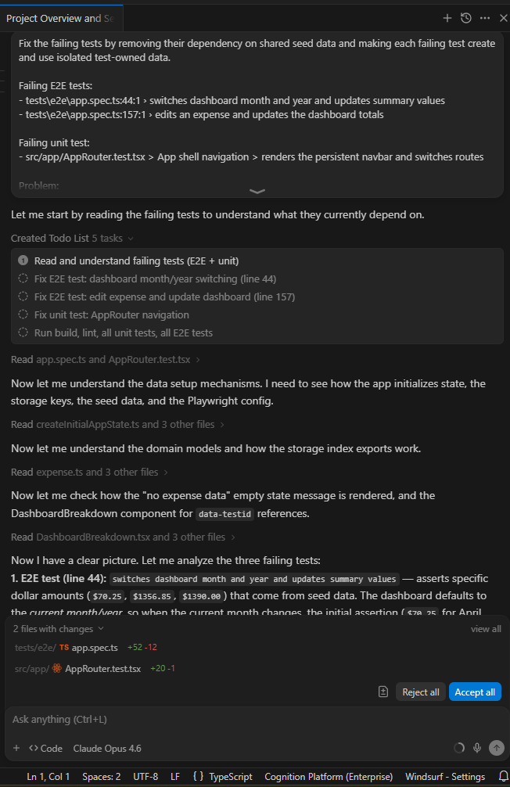
End with Plan Mode to replace the bar chart with donut pie chart.
- Show the implementation plan and accept the implementation
- Find the prompt in \Resources\3. Prompt Warm-up\Prompt_4-plan_mode.md
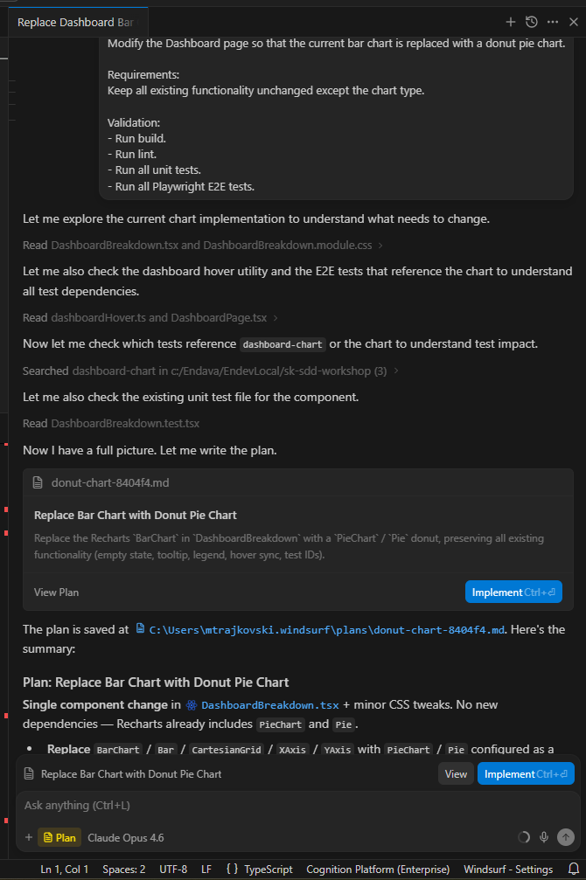

4. Workflows and Skills
Workflows and skills introduce reusable engineering automation.
- In Windsurf Cascade, use Workflows for explicit, repeatable runbooks you trigger yourself. - Use Skills for richer reusable capabilities that Cascade can choose automatically, especially when the task needs supporting files such as scripts, templates, examples, or checklists.
A Workflow is a manually invoked, step-by-step procedure, usually run with a slash command like /workshop.env.check.; use it when you want a predictable action sequence that the user explicitly starts.
Create a simple workflow:
1. In Windsurf open the folder SDD Workshop Windows\.windsurf\workflows
2. There create a new file named - workshop.env.check.md
3. Copy the markdown text from \Resources\4. Workflows & Skills\workshop.env.check.md and paste it in the previously created file, save (or just move the file inside .windsurf/workflows)
4. In cascade execute /workshop.env.check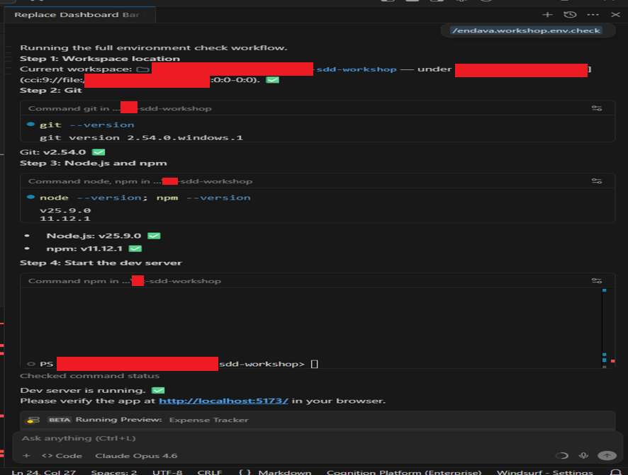
A Skill is reusable contextual guidance stored in .windsurf/skills/.../SKILL.md; use it when you want Cascade to automatically understand how to perform a specific kind of task.
Skills are more powerful when the procedure needs artifacts. A skill is a folder with a SKILL.md file and optional resources such as scripts, templates, checklists, style guides, rollback procedures, CI configs, or examples.
Create a simple skill:
1. In Windsurf open the folder SDD Workshop Windows\
2. There create a folder named skills and inside this create a folder named workshop.validator
3. Inside that create a new file named - SKILL.md
4. Copy the markdown text from \Resources\4. Workflows & Skills\skills\workshop.validator\SKILL.md and paste it in the previously created file, save (or just move the whole folder skills inside .windsurf)
5. In cascade invoke the skill with this prompt “Validate the workshop solution”.
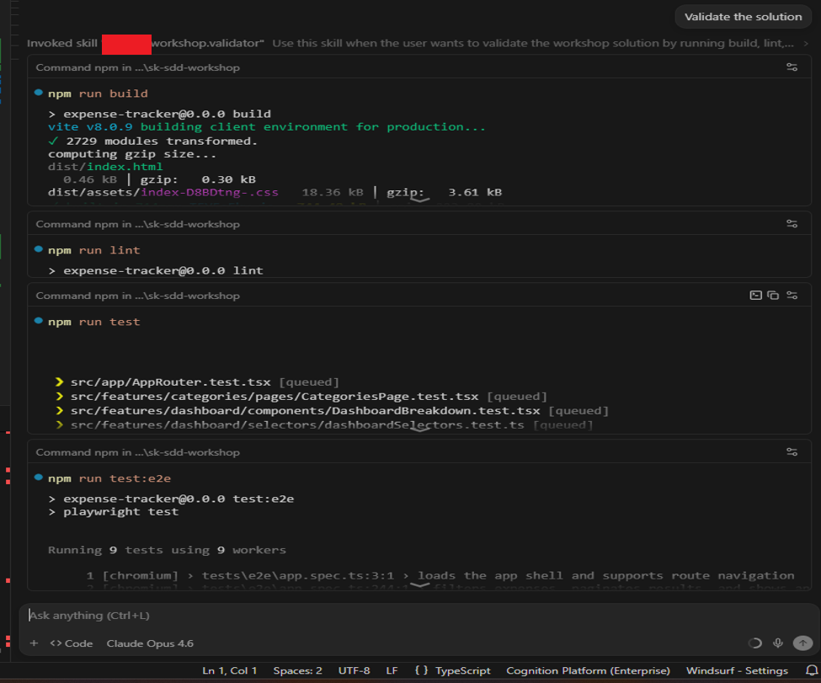

5. Spec-Driven Development
This workshop is not about asking an AI tool to “build something” and then hoping the result is good enough. That approach is often called vibe coding.
That can be useful for experiments, prototypes, or quick throwaway ideas. But it becomes risky when we are working in a real codebase.
So instead of jumping directly from idea to implementation, Spec-Driven Development gives us a more controlled process.
In practice, Spec-Driven Development means using the specification as the main source of truth. We do not start with code. We start with intent. We describe the feature, the expected behavior, constraints, user flows, acceptance criteria, and important assumptions. Only after that do we move toward planning, tasks, and implementation.
This is important because AI tools are very sensitive to context. If the context is vague, the output will also be vague. If the requirement is incomplete, the implementation may look impressive but still be wrong. SDD helps us make the context explicit before code is generated.
Before we start building the application we must write the constitution, it tells the project what principles it must obey – it is the project’s operating agreement for Spec Kit.
First, we write the specification: what we want to build.
Then we do clarification: what is missing, unclear, or assumed.
After that comes planning: how we should technically build it.
Then we create tasks: small implementation steps that can be reviewed and executed.
Then we run analysis to check whether the specification, plan, and tasks are consistent.
Only after that do we move to implementation.
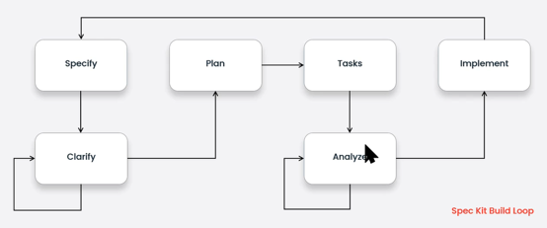

6. Spec Kit bootstrap / verify and explain structure
Resources:
GitHub repo - https://github.com/github/spec-kit
Spec Kit documentation - https://github.github.com/spec-kit
Spec Kit installation - https://github.github.com/spec-kit/installation.html
Spec Kit quick start - https://github.github.com/spec-kit/quickstart.html
For this demo use the folder that does not have Spec Kit installed, named SDD Workshop Empty
So for this demo use WSL with Ubuntu distro (or MacOS).
- python3 is included in all modern ubuntu versions (if missing install python)
- Install uv uvx
curl -LsSf https://astral.sh/uv/install.sh | sh
- Install Spec Kit one time – in existing project
uvx --from git+https://github.com/github/spec-kit.git specify init --here
Note: There are 2 parameters like --integration and --script that allows to choose the agent (windsurf, codex,etc…) and the script (ps or sh)
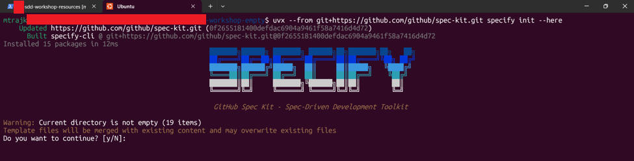Choose y and continue
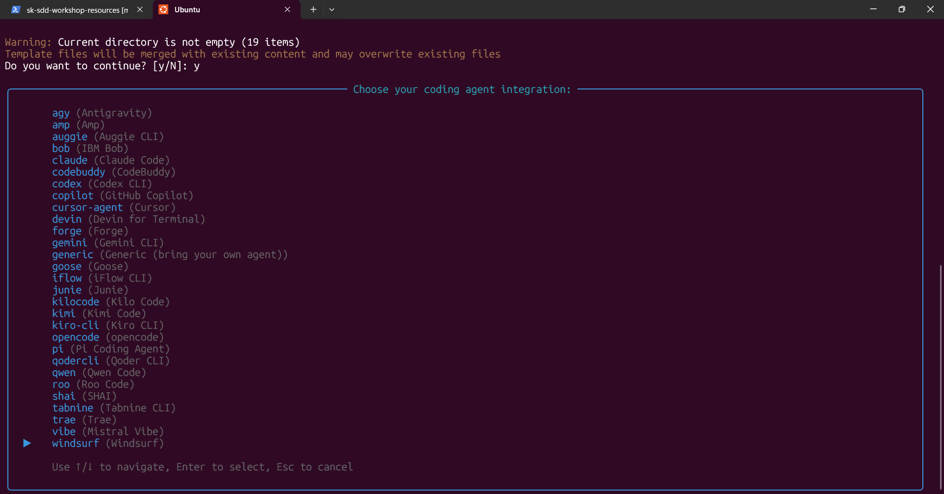
Choose windsurf and continue
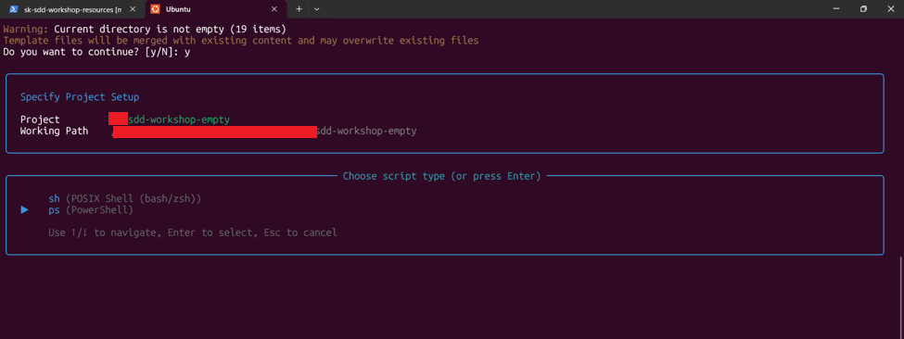
Choose ps and continue
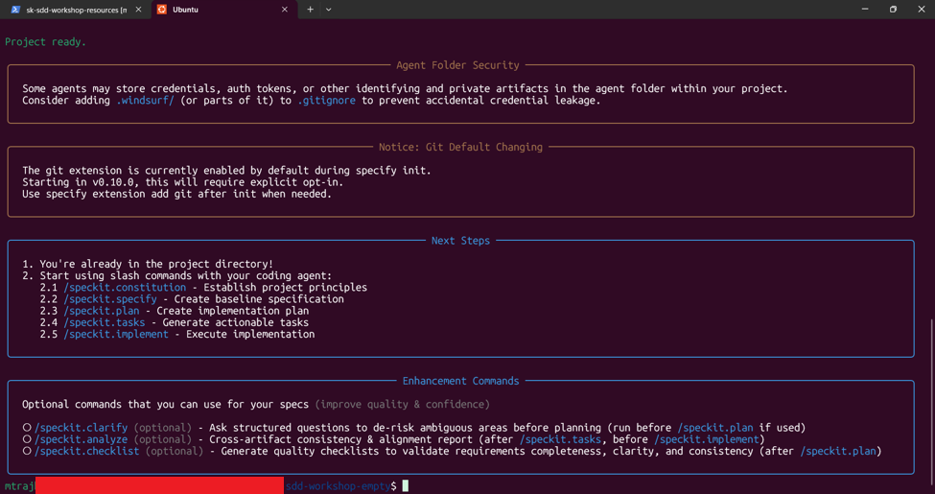
The project is setup successfully with Spec Kit for Windsurf IDE and PowerShell scripts
Explain the 2 newly created folders, .specify and .windsurf
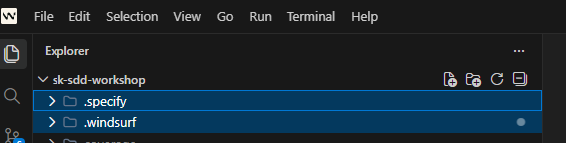

In .specify we have all the scripts, templates, memories (constitution) used by the spec kit logic (all the spec kit related configuration and artefacts are located here)
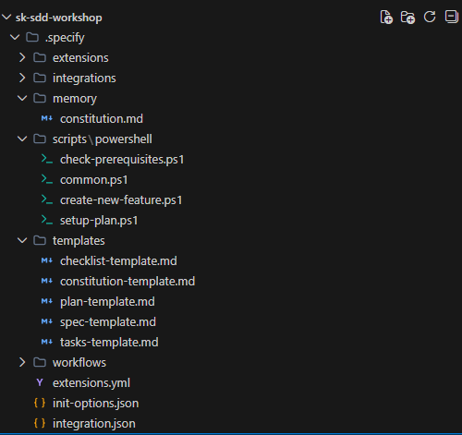
In .windsurf we have all the workflows, skills, rules that the windsurf is using (all the windsurf configuration and artefacts are located here)
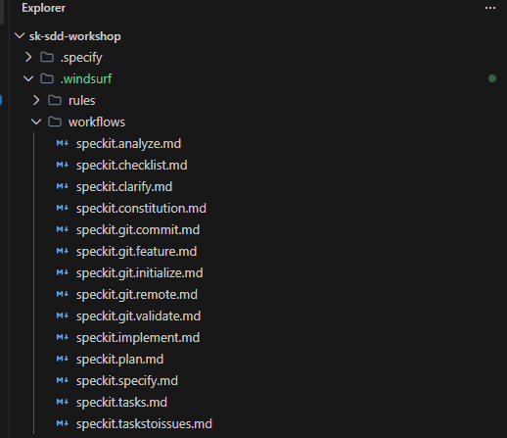

7. Guided end-to-end feature implementation
AGENTS.md vs constitution.md vs README.md
AGENTS.md
Use AGENTS.md if you want durable, team-shared instructions for the AI Coding Agents (in this case the Cascade). It tells the agent how to behave.
AGENTS.md = agent behavior and project conventions used by Windsurf/Cascade.
constitution.md
The constitution is the project’s operating agreement for GitHub Spec Kit. The constitution tells the project what principles it must obey.
constitution.md = project principles and governance used by GitHub Spec Kit.
README.md
README is the project’s front door for humans. Written for humans.
README.md = human-facing project introduction.

Required for the normal workflow
1. /speckit.constitution - Establish project principles (executed only once when the project is established)
2. /speckit.specify - Create baseline specification
3. /speckit.plan - Create implementation plan
4. /speckit.tasks - Generate actionable tasks
5. /speckit.implement - Execute implementation
Optional but often useful
1. /speckit.clarify - Ask structured questions to de-risk ambiguous areas before planning (run before /speckit.plan if used)
2. /speckit.analyze - Cross-artifact consistency & alignment report (after /speckit.tasks, before /speckit.implement)
3. /speckit.checklist - Generate quality checklists to validate requirements completeness, clarity, and consistency (after /speckit.plan)
Key Principles
- Be explicit about what you're building and why
- Don't focus on tech stack during specification phase
- Iterate and refine your specifications before implementation
- Validate the plan before coding begins
- Let the coding agent handle the implementation details
Demo
In this demo, with respect to the time, we’ll execute only the 5 mandatory commands:
constitution, specify, plan, tasks, implement.
Only the first 2 commands (constitution and specify) will be invoked with prompt/input.
The goal in this exercise is to explain the created files, specs with completing the whole flow and implementing a simple feature.

1. Start with /speckit.constitution
- show the changes in the constitution file from .specify\memory\constitution.md
- Find the prompts in \Resources\7. Guided SDD Feature Implementation\Prompt_1-constitution.md
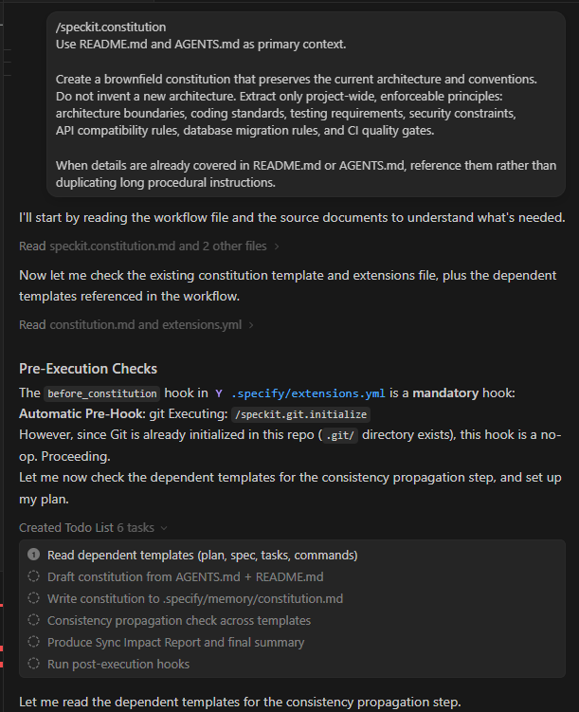

2. Continue with /speckit.specify
- show the folder and files generated in /specs – there will be 2 available files spec.md and checklists/requirements.md
- Find the prompts in \Resources\7. Guided SDD Feature Implementation\Prompt_2-specify.md
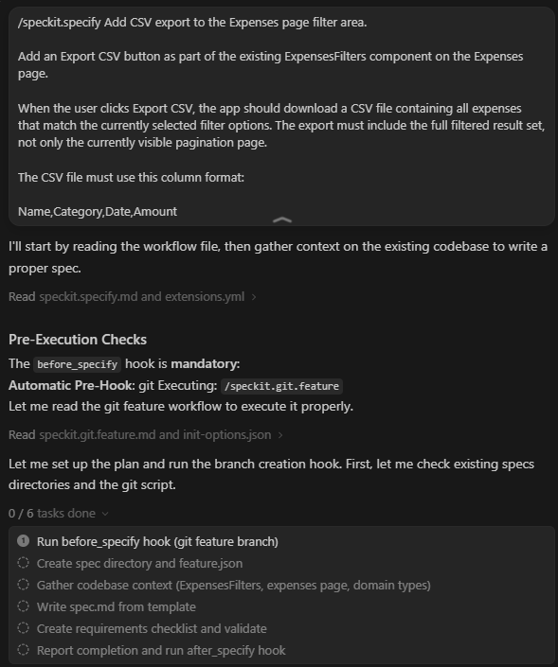
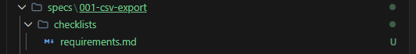

3. Continue with /speckit.plan
- without input
- show the new files generated like plan.md
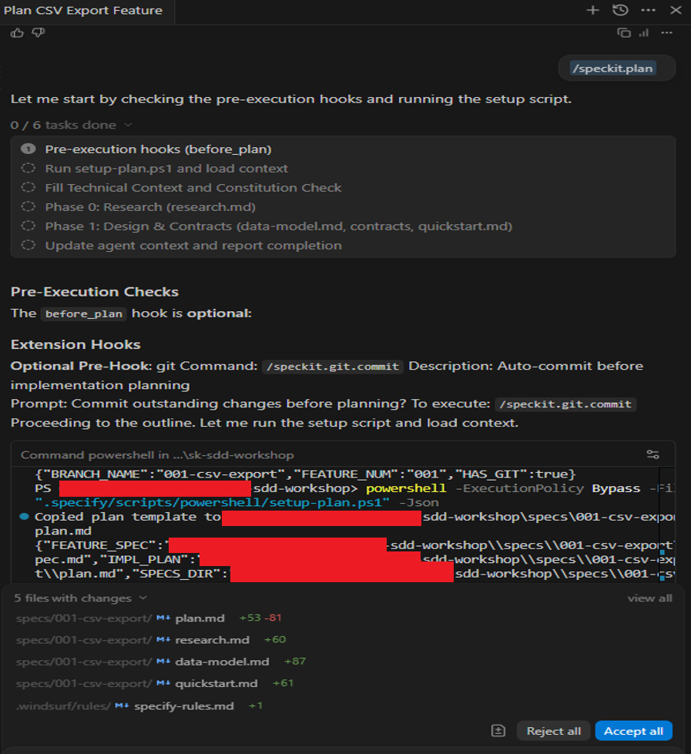
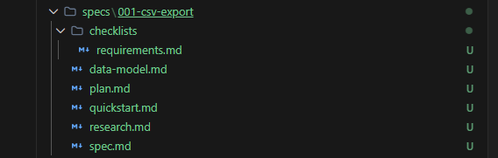
4. Continue with /speckit.tasks
- without input
- show the new files generated like tasks.md
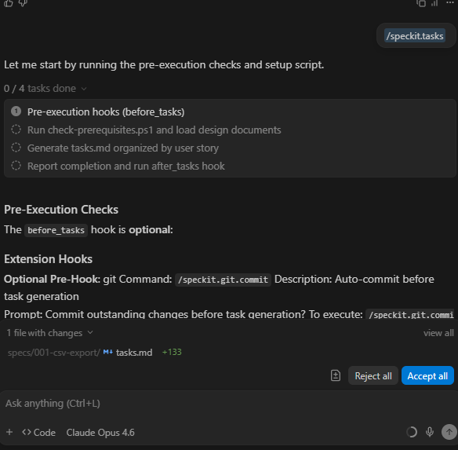
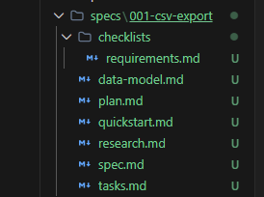
5. Continue with /speckit.implement
- without input
- show the changes in the code
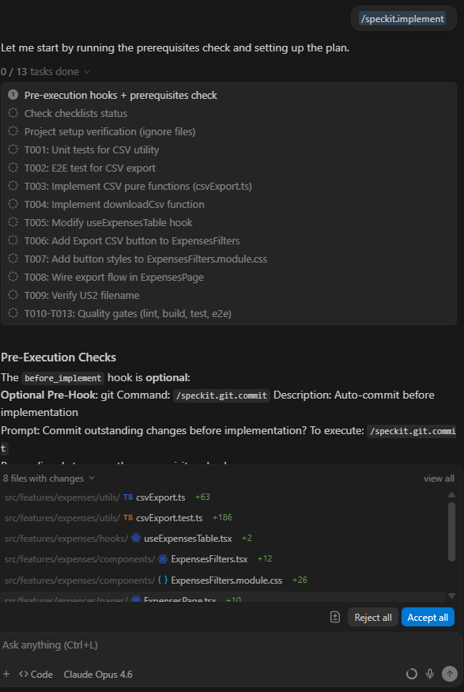

8. Solo exercise
For this part we have 25 minutes, so the attendees could implement some small feature that will need 3-4 working days to be implemented manually.
The attendees could now play with the clarify and analyze commands in loop if needed.
Constitution command is not needed in this step, it was already executed in the previous.
1. /speckit.specify - Create baseline specification
2. /speckit.clarify - Ask structured questions to de-risk ambiguous areas before planning
3. /speckit.plan - Create implementation plan
4. /speckit.tasks - Generate actionable tasks
5. /speckit.analyze - Cross-artifact consistency & alignment report
6. /speckit.implement - Execute implementation
Ideas
1. Click dashboard category to filter Expenses page.
2. Dashboard chart type toggle.
3. Bulk select and delete expenses.
4. Category rename.
Find the prompts in \Resources\8. Solo SDD Feature Implementation\

9. Q&A
Questions and discussion.

